GGKLI September 23, 2012

GROUP 3 and 4

Yagna

* *Yagna* means selfless sacrifice for noble purposes; Sacrificing the ego, selfishness and material attachments.
* *Yagna* teaches living in a society in harmony and a lifestyle to promote and protect higher humane values in the society.

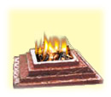

* **Yagna comprises of three elements:**
* Worship of Gods - Appreciating noble qualities
* Togetherness - Unity
* Charity - Welfare/Donation

**Types of Yagna**

* *Seva Yagna-* altruist service of the society
* *Gnana Yagna-* service of people by enlightening their lives in the glow of knowledge and education
* *Prama Yagna-* saving the lives of people suffering and in agony and inspiring liveliness and respect for life in them

**Things Used in Yagna**

* *Wood-* sandalwood, pipal, mango

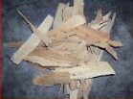

* Havankund



* *Odoriferous Substances-* saffron, musk, camphor
* *Substances with Healthy Constituents-* milk, clarified butter, fruit, & grains such as rice
* *Sweet Substances-* sugar, dried grapes, honey
* *Medicinal Herbs-* somalata, brahmi, shankhpushpi, nagkesar, mulhati

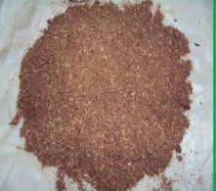

**Science and Yagna**

* Industrial wastes, rapid urbanization, deforestation, air and water pollution, disturbances in the ozone layer formation, and radioactive waves have destabilized the human, animal and plant life cycles. The ecological imbalances caused by these acts of ‘civilized men’ has resulted into a disastrous threat to the entire planet.
* Experimental studies show that the incidence of physical ailments, sickness and disease are reduced in the houses where the *Yagna* (Agnihotra) is regularly performed because it creates a pure, nutritional and medicinal atmosphere. It renews the brain cells, revitalizes the skin, purifies blood and prevents the growth of pathogenic organisms.

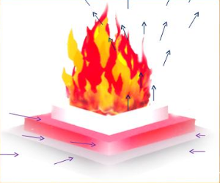

* Cow’s milk contains great power of protection from atomic radiation
  + If cow’s ghee is put into the *Yagna* fire, its fumes lessen the effect of atomic radiation to a great extent.
* Removes foul odors- Various oils such as camphor and clove diffuse into the atmosphere
* Removes bacteria- The oxidation of hydrocarbons during *Yagna* produces formic acid and acetic acid, both of which are good disinfectants.
* Removes insects- Non-bacterial parasites either get killed or are driven away when they come in contact with volatile oils such as camphor
* Affects plants and animals- The ash from the *Yagna* serves as a natural fertilizer and maintains ecological balance.

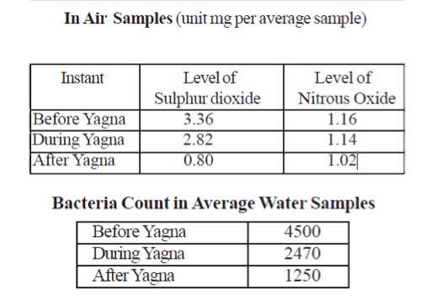

**Mantras and Yagna**

* The collective chanting of *Mantras* in specific rhythm in front of the *Yagna* flames gives rise to unique sound waves which have infinite radiant effects in the outer space.

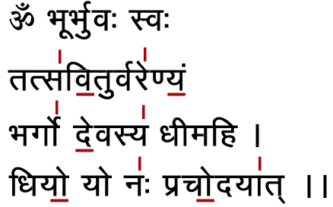

Medical Uses of Yagna

* Yagna can be used to treat:
  + - Malaria
    - Hypertension
    - Diabetes
    - Asthma
    - Cardiac Problems
    - Mental Disability
    - Arthritis
    - Cancer
    - Aids

