He takes care of me
He takes care of everybody
He cares for all animals
He cares for all plants
He creates everything
He is the great organizer
He is the great director
He is seen as dear mom
He is seen as dear dad
He is seen as our friend
He is seen everywhere
He is seen any where
He is a great God.

I believe there is God
He may be abode in the sky
He may be living on earth
May be he is in water
May be he is in air
He is there ! He is there !
Dharma, Religion and Spirituality

Some say Jesus is the Great
Others say Lord Rama is the God
Some say Mohammad is great
Some say Buddha is great
Some say lord Krishna is great
Some say lord Shiva is great
Some say Mahavira is the real
Some say Guru Nanak is great

All they preach us is very simple, very sound.
- Love young ones
- Respect elders
- Help the less
fortunate in need
- Be on the righteous path

Please do not be selfish
do not hurt any body
Be happy
let others be happy
Live and let live
Is the essence of all

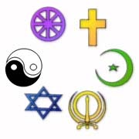

True religion preaches us
Not to hurt anybody
Not to torture anybody
Not to harass anybody
Not to commit outrage
Not to hate anybody
Not to kill anybody

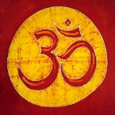

Some like bread, You like donuts
She likes pretzels, He likes chips
Somebody likes pizza, Some like Lasagna
Other like pasta
Everybody has their choice
Though corn in common to rejoice

Open your eyes
Open your minds
Open your hearts
Open your arms
Embrace one another
After all God had
made them all

Let peace be prevail everywhere
Let love be prevail everywhere
Let true friendship prevail everywhere
Let brotherhood prevail everywhere
Let happiness prevail everywhere
Let we prosper
Let others prosper
May God bless us all.

