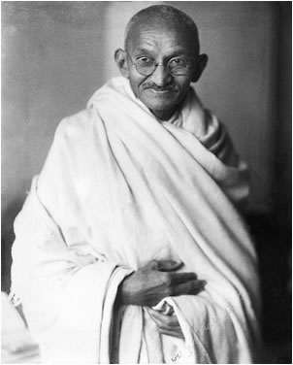
Factsheet about Mahatma Gandhi
Full Name: Mohandas Karamchand Gandhi
Birthdate: October 2nd, 1869
Death: January 30th, 1948 (assassinated at age 78)
Birthplace: Porbandar, Gujarat, India
Educational Background: Lawyer
Nicknames: Mahatma (Great Soul), Bapu (Father), Father of the Nation (India)
Father: Karamchand Gandhi
Mother: Putlibai
Wife: Kasturba
Children: Harilal Gandhi (b. 1888), Manilal Gandhi (b.1892), Ramdas Gandhi (b. 1897), Devdas Gandhi (b. 1900)
Primary Place of Residence: Sabarmati Ashram
Principles he lived by:
- Satya (Truth) - Gandhiji declared that no body or force on earth can defeat truth. Gandhiji himself said that “Truth is God” He said that the most important battle in his life was to discover truth. In order to do so, he had to fight his own demons, fears and insecurities.
- Ahimsa (Non-violence) – Nonviolence in all aspects, in thought as well as action. However, it should not be a substitute for cowardice in order to cover up fear. Gandhiji said himself, “when there is only a choice between cowardice and violence, I would advise violence.”
- Vegetarianism – Gandhiji used his own body as a lab to experiment with the different types of food he put into his body. This included experiments with eating meat as a youth. However, as Gandhiji became older, he realized from the various experiments on his own body that a vegetarian diet gave him much more clarity in thinking and energy with enabled him to accomplish many of the things he is known for in his life. He also promoted vegetarianism because of economic reasons. During the early 1900’s in India, A vegetarian diet was much cheaper than having a diet which included meat.
- Lower Caste Removal – Gandhiji claimed that there is no such thing as lower caste people. Everyone is a child of God and equal in His eyes regardless of race, color, creed, etc. Being a Brahmin is not necessarily by birth, but by the actions one takes in his/her lifetime.
- Self Reliance – We should be responsible for our own livelihood. If we don’t take matters into our own hands and take or of our needs, then it is almost like driving a car without a steering wheel. We will be taken to places in life, where we don’t want to go.
- Simplicity – Throughout most of his life, Gandhiji lead a life of simplicity. As witnessed in the picture above, he commonly wore a simple dhoti and a shawl. In addition, Gandhiji initiated a movement in India where he encouraged people to wear clothes that were spun with a spinning wheel at home (Khadi). It is the primary reason why we have a wheel on our Indian National Flag.

