Matrudevobhava – Treat your mother as God

[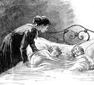](http://www.google.com/imgres?imgurl=http://www.spokesableman.com/spokesableman.com/Blog/Entries/2009/5/4_Mother%E2%80%99s_Day_files/mothers-day-clipart-4.jpg&imgrefurl=http://www.spokesableman.com/spokesableman.com/Blog/Entries/2009/5/4_Mother%E2%80%99s_Day.html&usg=__n_l5iWY2-9nEysKWx0K8_Tyjsy0=&h=333&w=365&sz=62&hl=en&start=175&itbs=1&tbnid=CvxX0LQaVra-gM:&tbnh=110&tbnw=121&prev=/images?q=mother's+day+clip+art&start=168&hl=en&sa=N&gbv=2&ndsp=21&tbs=isch:1)

Our mom

* Mother is considered as Brahma – our creator
* Mother is our first Guru – who introduced us to the world and taught about different things.
* Mothers do things for us without expecting anything in return! – Her love is incomparable. She makes all sacrifices to make us happy.
* Always listen to her and never do anything that might hurt her feelings.
* Always be and behave in such a way that she feels proud to be your mother.
* Remember! Any time she yells at you, its for your own good, because she wants you to be a better person in life. So please follow her advice.

Story:

One boy had only one eye. His mother also had only one eye. He felt, his mother looked scary and ugly. He was very embarrassed by her. He never liked her to be around him. She was a single mother and worked really hard to raise him. Once he grew big, he left house. After that he never kept any relation with his mother. He got married. He had a child. After few years, one day, the mother came to see him. The son opened the door. He got very disappointed seeing her. He refused to recognize her and kicked her out. She left. After few months, he got news that she is no more. He went to her house. She found a letter that said – when he was a child; he had gotten into an accident and lost both his eyes. The mother donated his one eye to him. Such was the love of a mother for his son! The son realized what a great mistake he had done. He cried and cried and cried but no way to apologies.

More stories –

* Lord Rama, Shravan etc. are the examples of an ideal sons
* Shakauntala and MataSita, Jijabai single handedly raised their children. Examples of ideal mothers - All mothers are ideal mothers!

Mother Earth

[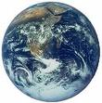](http://www.ajnacenter.com/ajna/images/BigEarth.jpg)

* One more mother, who gives us food to eat, water to drink and air to breath. Basically we cannot live without it.
* Also when we die, our birth mother will put us down on the floor after sometime but this mother accepts us in her lap and puts us to sleep for good.
* Most importantly, Mother earth also does all these without any expectations in return.
* That is why we do “Pruthvi Poojan” during all our worships. We can show our reverence to mother earth by keeping it clean, not littering and spreading awareness about – GO GREEN in order to save it from overheating.

[](http://www.google.com/imgres?imgurl=http://www.cgipromotions.com/images/GoGreenFlier.jpg&imgrefurl=http://www.cgipromotions.com/gogreen.html&usg=__9GfsDee1EovksLm_nQGq_nz7AnU=&h=494&w=500&sz=231&hl=en&start=38&itbs=1&tbnid=GPvzVLwtV2sB6M:&tbnh=128&tbnw=130&prev=/images?q=go+green&start=21&hl=en&sa=N&gbv=2&ndsp=21&tbs=isch:1)

[](http://www.google.com/imgres?imgurl=http://static.squidoo.com/resize/squidoo_images/-1/lens2365337_1231254465a_million_ways_to_go_green_badge.jpg&imgrefurl=http://www.squidoo.com/million-ways-to-go-green&usg=__-7QkdnJPtiyM6W13W2sPbdgtQU0=&h=241&w=250&sz=50&hl=en&start=69&itbs=1&tbnid=rwjqoqBnt1dTmM:&tbnh=107&tbnw=111&prev=/images?q=go+green&start=63&hl=en&sa=N&gbv=2&ndsp=21&tbs=isch:1)

[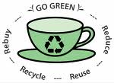](http://www.google.com/imgres?imgurl=http://www.tea4u.com/GoGreenTeaRooms/uploaded_images/GoGreenTearoomLogo-752582.png&imgrefurl=http://www.tea4u.com/GoGreenTeaRooms/&usg=__Cby9rBa4eyLnmv1mDOdMMDJk9h0=&h=1161&w=1600&sz=329&hl=en&start=166&itbs=1&tbnid=OREnirSSYgzJBM:&tbnh=109&tbnw=150&prev=/images?q=go+green&start=147&hl=en&sa=N&gbv=2&ndsp=21&tbs=isch:1)

[](http://www.google.com/imgres?imgurl=http://hemakumar.fastlink.in/fun_files/motherearth.jpg&imgrefurl=http://hemakumar.fastlink.in/fun.html&usg=__ouNlOwEtVRskBOG_KPXwb85U0U4=&h=400&w=300&sz=18&hl=en&start=35&itbs=1&tbnid=ETSUVDts8ntNdM:&tbnh=124&tbnw=93&prev=/images?q=mother+earth&start=21&hl=en&sa=N&gbv=2&ndsp=21&tbs=isch:1)

We must pray to mother earth as we wake up every morning and put our feet on floor from bed.

Show ways of saving earth – Going Green

1)

2)

3)

4)

5)

6)

Mother India:

India is our mother because either our parents or our ancestors were born in India. We follow Indian culture. India is the oldest country of the world. Our sanskriti is the greatest because; it teaches us to accept everyone as our brothers and sisters. We do not make differences among people because of religion or color etc. We have given the greatest gifts to the world, like the number Zero, the game Chess, the sport of Polo, Chanakya was a great economist, ………

Please check files ------

1. Facts about India
2. Great Indians

Write reasons for “Why do you feel proud to be an Indian”

1)

2)

3)

4)

5)

6)

7)

8)

Mother Shruti(Vedas):

Ekoham bahusyami (Lord Vishnu wanted to manifest Himself in different forms)

Lotus appeared from His naval and he created Lord Brahma and gave him a job to create a universe where a lot like Him can flourish.

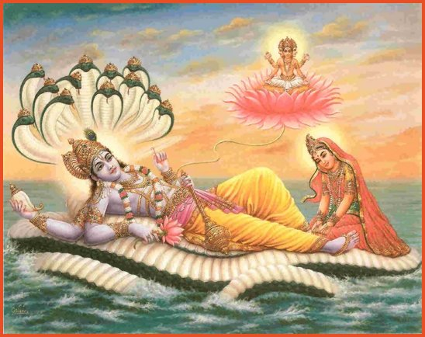

Lord Brahma created 5 essential elements (earth, sky, water, air, fire). The atoms of which combined with one another and formed physical bodies.

C:\Program Files\Microsoft Office\MEDIA\CAGCAT10\j0281904.wmf

[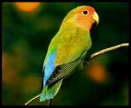](http://rds.yahoo.com/_ylt=A0WTefZXFfxLUA8AoaiJzbkF;_ylu=X3oDMTBpc2ozM2gzBHBvcwM0BHNlYwNzcgR2dGlkAw--/SIG=1k09snsqb/EXP=1274898135/**http:/images.search.yahoo.com/images/view?back=http://images.search.yahoo.com/search/images?p=birds&ei=UTF-8&fr=yfp-t-701&w=500&h=412&imgurl=media-content.flixya.com.s3.amazonaws.com/files/rafiq216962.jpg?AWSAccessKeyId=1TKE66PETJJHG8051M02&amp;Expires=2117774364&amp;Signature=tVEYYIf+SMOO5kHwGAxR3pUPXds=&rurl=http://www.flixya.com/photo/216962/Birds&size=129k&name=Birds&p=birds&oid=bd36545b5f0be496&fr2=&no=4&tt=19675124&sigr=1182fqvnl&sigi=159vmjimq&sigb=12a63f2vr)

C:\Program Files\Microsoft Office\MEDIA\CAGCAT10\j0216724.wmf

[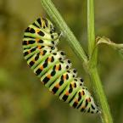](http://rds.yahoo.com/_ylt=A0WTefVFFvxLal0AJbGJzbkF;_ylu=X3oDMTBpcWpidGtpBHBvcwM4BHNlYwNzcgR2dGlkAw--/SIG=1i9bo8fpa/EXP=1274898373/**http:/images.search.yahoo.com/images/view?back=http://images.search.yahoo.com/search/images?p=insects&b=1&ni=18&ei=utf-8&xargs=0&pstart=1&fr=yfp-t-701&w=640&h=640&imgurl=pics4.picvi.com/media/pics/2008/07/02/Insects/09.jpg&rurl=http://www.picvi.com/2008/07/02/insects-2&size=70k&name=Insects&p=insects&oid=04e6c7a0585c1d30&fr2=&no=8&tt=4728830&b=1&ni=18&sigr=119k36a3h&sigi=11kdoospp&sigb=137evuo1g)

C:\Program Files\Microsoft Office\MEDIA\CAGCAT10\j0332364.wmf

Lord Brahma then made them alive by putting Life Force (Pran-Fraction of God) in each of them.

Lord Brahma created 24 syllable Mantra (the great Gayatri Mantra) to guide for how to live life; Our politics, economics, health, Dharma, desires etc. ||Om bhur bhuvah swah tat savitur varenyam bhargo devasya dheemahi dhiyo onah prachodayat ||

People heard the meaning of each syllable of this greatest mantra in divine voice (Shrvan – hearing). They explained it to others. Thus a lot of knowledge ccumulated.

Risi Krishnadwaipayan Vyasa – compiled all knowledge into four classes: Rigveda(Dharma), Samveda(Desires), Yajurveda(Politics), Atharvaveda(Economics) Thus Vedas are known as Shruties. They are the Brahmgyan, the Ultimate knowledge.

Mother Cow:

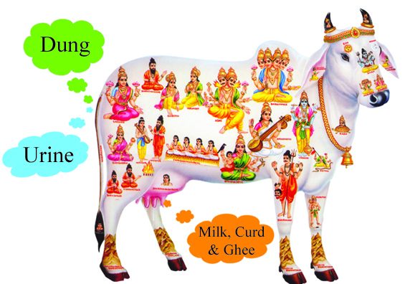

Cows are considered Sacred in Hindu religion. The cow is treated as holy because he/she provides strength to plow the fields, milk to give nutrition to humans and leather from their skins upon death. Because of all they provide cows are considered the mothers to humans and therefore should be treated with respect and never eaten.

Cow is abode of gods. She is Kamdhenu (desire fulfiller) personified. All the demigods reside in the body of a Cow. She is receiver of the auspicious rays from all the planets. Thus she contains influences of all constellations. Wherever there is a cow, blessings of all gods are there. Cow is the only divine living being that has a SURYA KETU NADI (vein connected to sun) passing through her backbone. Therefore the cow's milk, butter and ghee has golden hue. This is because Surya ketu Vein, on interaction with solar rays produces gold salts in her blood. These salts are present in the cow's milk and cow's other bodily fluids, which miraculously cures many diseases.

Cow’s Milk and Curd: Is a complete meal, full of protein, vitamin, carbohydrates , fat and other nutrients.

Cow’s Ghee: Cow’s ghee is very pure. It does not get spoiled even after many years. Havans are done with Desi cow’s ghee. When this ghee burns with sugar, it creates anti oxidants and cleans the environment. It also purifies our blood.

Cow’s Urine:

* The Western research has shown that Cow's Urine is antibiotic, antimicrobial, antifungal and anti-tuberculosis. Cow urine distillate has been proven as activity enhancer and availability facilitator for bioactive molecules including anti-infective and anti-cancer agents.
* Cow urine balances the three doshas (mucous, bile, and air). Thus it is able to cure all diseases. It boosts the immune system, serves as a complete detoxifier, and as a health promoting anti-oxidant. It also enhances brain power and strengthens the heart while bringing your consciousness to a higher level of goodness. Generally, it repairs and regenerates damaged tissues and cells. Very effective in obesity, controlling cholesterol levels, reducing stones, swelling, and joint pains. Also cures respiratory problems. It is useful in all kinds of children's cough and other diseases. It gives strength and energy. Also serves as an anti-bacterial agent. GOMUTRA serves as a purification element. It may be sprinkled around the work places, residential areas, and all over the body. It is also essential in abhiseka (bathing) of the deities and yajna (sacrifice) ceremonies.
* It promote regular and healthy menstrual cycle and prevents other related menstrual problems such as weakness due to blood loss during periods, nervousness, dizziness, weakness of heart, gassiness, burning sensation of palm and feet, headache, restlessness, sleeplessness, and pimples. It is generally good for reproductive health. If before delivery it is taken regularly, normal delivery is guaranteed.
* It is useful for eye related discomforts: red eyes, burning and itching sensation of eyes, headache due to eye problem, tension, immature cataract, watery eyes, etc. Prevents the early stage of cataract and promotes good eyesight. Use daily for effective result.

Cow’s Dung:

Traditional usefulness of Cow dung in Agriculture as a manure; Special developments used as spiritual farming, bio-gas production and use of slurry for better yield, wormi culture, etc Organic and Spiritual farming tools using Cow urine and cow-dung is getting more popular due to its cost-effectiveness and increasing yields and soil enrichment

Cow’s dung is anti-bacterial that exfoliates the skin leaving it fresh and glowing. It protects the skin from leprosy, cirrhosis, and other skin diseases. There are many advantages of cow dung soap. There will be no fear of modern day pollution, radiation, and infection if one takes a bath daily with cow dung. It is beneficial for persons with skin diseases, ringworm, eczema, psoriasis, and infected wounds. For acne, pimples, skin diseases, and heat rash. Makes the face effulgent. Wrinkles and spots are destroyed and will also cure dandruff.

Also used in making DANTA MANJANAM as a preventive and cure for mouth infections and to add strength to the teeth and gums. Effective on all oral diseases such as tooth worms and stops tooth decay. It also reduces the sensitivity in teeth, the swelling of gums, cures ulcers of the tongue, sore throats, tonsillitis, and pyorrhea. It also refreshes the mouth and is a breath freshener.  
  
**Panchgavya** (cow's urine, dung, milk, curd & ghee)**:**

The following are a subset of the diseases that are completely cured by Panchgavya System of Medicine:-

**Several disorders such as** 1) Leucoderma, 2) Hyperlipidemia, 3) Arthritis, 4) Renal disorders, 5) Dietary disorders, 6) Gastrointestinal track disorders, 7) Acidity, 8) Asthma, 9) All kinds of cancer, 10) Blood sugar, 11) Hypertension, 12) All kinds of skin diseases, 13) Mentally retarded, 14) Stomach ache, 15) Gas problems, 16) Other stomach diseases, 17) Eczema, 18) eye diseases, 19) All mouth diseases, 20) White spots, 21) Vitiligo, 22) Leprosy cough, 23) Breathlessness, 24) Jaundice, 25) Anaemia, 26) Dysentry, 27) Joint pains, 28) Cancer, 29) HIV etc.

The Sloka from Ayurveda which describes Panchgavya:

***Gavyam Pavitram cha Rasayanam cha, Pathayam cha Hridyam Balbudhim. Aayuh Pradm Raktavikarhari, Tridoshridogvisaphm syat.***

Translation: The five elements that come from the sacred indian cow are sacred and are medicine for the heart, they give strenght and enhances the intellect. They give long life, purify the blood, balance the Vath, Pith and Kafam doshas. They cure all diseases and detoxifies the body.

References from Vedas: In a calm voice a Cow named Nandini says to King Dilip (coming in Dynasty of King Raghu): ***na kevalam payasa prasutim ve hi man kam dugham prasannam***

Translation: Whenever I am pleased and happy I can fulfill all desires. Don't consider me to be just milk supplier.

***matrah sarva bhutanam gavah sarv sukh prada***

Translation: The cow being mother of all living entities gives all pleasures to everyone.

If  by any chance some poisonous or harmful material enters cow's food, she absorbs it in her flesh(Muscles and fat). She does not let it go into cow urine, cow dung or milk or releases in very small quantity. These results were compared by other researchers around the world with other animals by feeding them various items and then testing milk and urine. Therefore cow urine and dung are pure and removes toxins. Cow milk is certainly anti-toxin. Cow urine is included in "panchgavya". "Panchgavya" is said to be curer of all diseases from bone to skin of all life.

***yatvagasthi gatam papam dehe tishthti mamke prasnat panchgavyasya dahasagnirivendhnam***

Translation: From skin to bones, whatever sins (diseases) are in my body, are destroyed by panchgavya just as fire destroys fuel.