NATIONAL BIRD OF INDIA : PEACOCK NATIONAL ANIMAL OF INDIA : TIGER
NATIONAL FLOWER OF INDIA : LOTUS

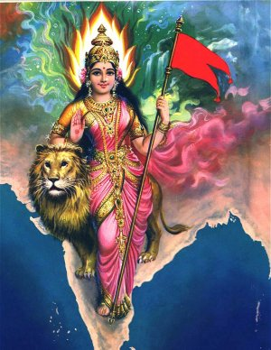

NATIONAL ANTHEM OF INDIA
" Jana Gana Mana Adhinayaka Jaya He
Bharat Bhagya Vidhata
Punjab Sindh Gujarat Maratha

Ashok Chakra
The Ashoka Wheel in the center of the white is the wheel of the law of dharma. Truth or satya, dharma or virtue ought to be the controlling principles us. Again, the wheel denotes motion. There is death in stagnation. There is life in movement. India should no more resist change, it must move and go forward. The wheel represents the ynamism of a peaceful change.”
Dravida Utkala Banga
Vindhya Himachal Yamuna Ganga

Kesari / Orange
ForTyag or Sacrifice for Nation

White : Truth and Purity in our actions

Green: Our relation with soil and plant life on which on which all lives depend

Ucchala Jaladhi Taranga
Tubh Shubha Name Jage
Tubh Shubha Ashisha Mange
Gahe Tubh Jaya Gata
Jan Gan Mangaldayak Jay He
Bharat Bhagya Vidhata
Jaye He ! Jaye He ! Jaye He !
Jaye,Jaye,Jaye,Jaye He "
Translation of The national anthem- Jana Gana Mana in English
Thou are the ruler of the minds of all people, dispenser of India's destiny.
The name rouses the hearts of Punjab, Sind, Gujurat and Maratha. Of the Dravid and Orissa and Bengal.
It Echoes in the hills of Vindhyas and Himalayas, mingles in the music of Yamuna and Ganga and is chanted by the waves of the Indian Sea.
They pray for your blessing and sing thy praise. The salvation of all people is thy hand, thou dispenser of India's destiny. Victory, Victory, Victory to thee.

The Jana Gana Mana was composed by Shri Rabindranath Tagore and first sung at the Calcutta session of the Indian National Congress on December 27th, 1911. It was adopted as the National Anthem of India on 24th January, 1950 by the Constituent Assembly. The first stanza (out of five stanzas) of the song forms the National Anthem.

