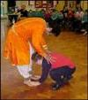
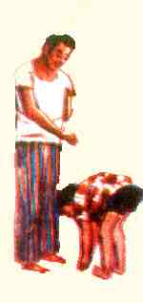
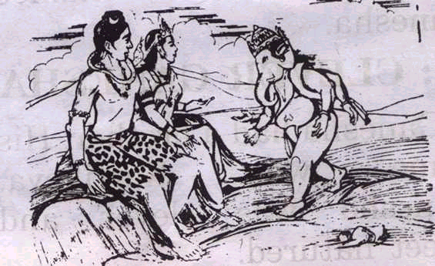

Touch your parent’s feet

Matru devo bhava, Pitru devo bhava

- Parents are the physical form of God. They gave you birth on this Earth, they love you, they sacrifice everything for your happiness. For e.g., when you go for a test, your parents pray to God for your success! They always pray to protect you from evils.
- When you touch their feet, parents give you blessings from deepest part of their heart.
- By touching elders’ feet, you automatically develop respect for them. If you respect them well, you become their favorite. They love you a lot.
- When you touch somebody’s feet, you absorb his/her energy into your body. You also awaken emotions in that person which are necessary for that person’s spiritual growth. So in a way you are doing good for that person too.
- In the morning a person is usually very peaceful and full of vitality. Blessings given with a peaceful mind come true. So always touch elders’ feet in the morning.

Abhivadan sheelasya nitya vrudhhop sevinah |
Chatvari tasya vardhante aayu aayuhu vidya yasho balam ||
One who touches elders’ feet everyday and does their Seva regularly
His longevity, name/fame, strength and ability to earn knowledge increases.

e.g. Markandeyarishi was alpa – aayu (He had a very short life of only 16 years) but he was used to touch his parents’ and all the elderly people’s feet. Once one rishi visited them. As usual Markandeya touched his feet. The rishi gave him blessings of “Long life”. Markandeya then went to the jungle and did penance of Lord Shiva and got a long life.
Lord Rama, Laxmana, Naradmuni, all Pandava brothers, Parvati, Ganga, Draupadi, Sita and all the great characters in Indian epics used to touch their parents feet.

Mata pitro stuyah pado nityam prakshalayet sutaha |
Tasya bhagirathi snana mahanyahani jayate ||

The child who touches his/her parents feet everyday, gets the benefits of Ganga snan everyday. (Bathing in Ganges is considered to make you pious and free of sins)
Nasti matuhu param teertham, putranam ch pitu statha |
Narayana samavetahi, chaiva paratra cha ||
There is no better Teerth(Holly place) for sons other than parent’s feet. Undoubtedly parents are like Lord Narayana for them in both worlds.

Ganesha Story:
On one occasion there was a mango to be given to the child who would go around the world and complete the trip first. Kartikeya, Ganesha’s younger brother was his competitor. While Kartikeya started his journey around the world, Ganesha simply walked around his parents, Lord Shiva and Parvati, who as Gods represent the whole universe. Ganesha claimed the prize!

